History of Art
For those applying for History of Art, in addition to your application on UCAS.com, please complete the written assignment detailed below in this document.
Name:
Date of UCAS application submission
Title of work of art you have analysed:

Please choose from ONE of the works of art below:
Choice A: Alesso Baldovinetti, Portrait of a Lady (Circa 1465)
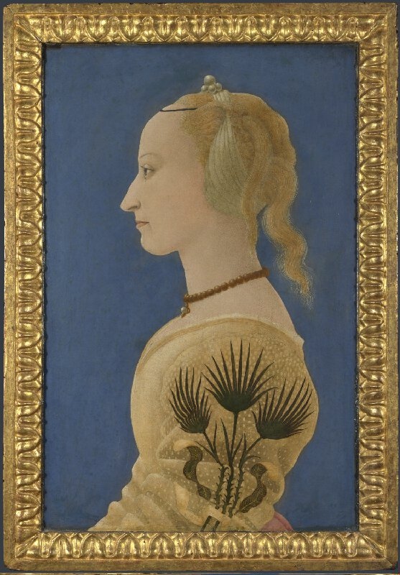

Choice B: J.M.W. Turner, Rain, steam and speed (1844)
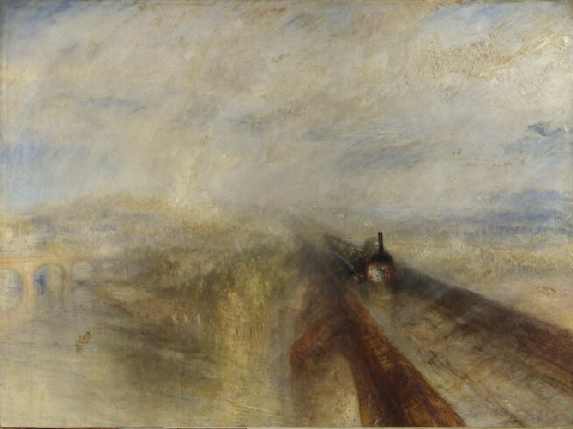

Choice C: Henry Moore, King and Queen (1952-1953)
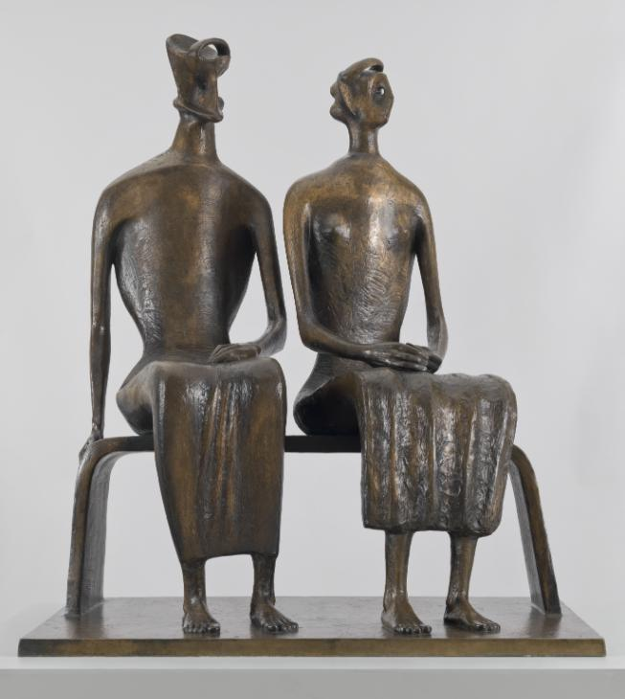

Please copy you response below:
Note: Only analyse one work of art. Please write 400 to 500 words.

