**History of Art**

For those applying for History of Art, in addition to your application on UCAS.com, please complete the written assignment detailed below in this document.

|  |
| --- |
| Name: |
| Date of UCAS application submission |
| Title of work of art you have analysed: |

Please choose from **ONE** of the works of art below:

**Choice A:** Alesso Baldovinetti, *Portrait of a Lady* (Circa 1465)

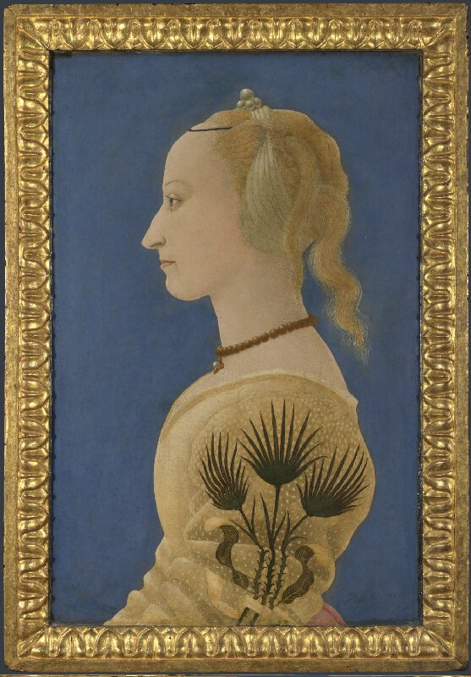

**Choice B:** J.M.W. Turner, *Rain, steam and speed* (1844)

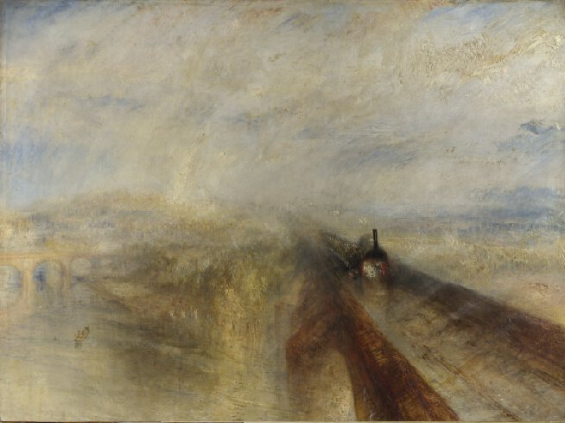

**Choice C:** Henry Moore, *King and Queen* (1952-1953)

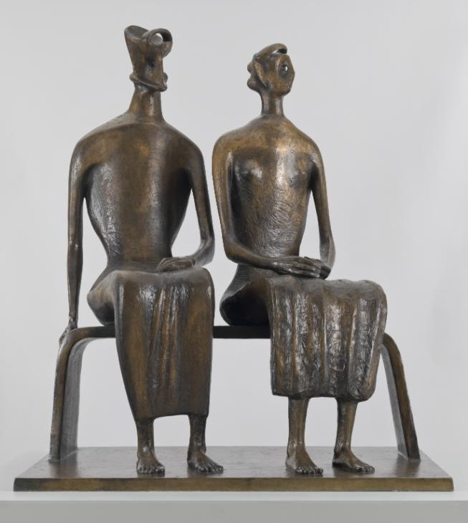

|  |
| --- |
| Please copy you response below:  *Note: Only analyse one work of art. Please write 400 to 500 words.* |