Tentative Program
For
The 10th Japan-China-ROK Youth Forum

A team of twenty (20) students and one faculty advisor each from China and ROK will participate in the Trilateral Youth Forum to be held at Sophia University in Tokyo. Forty (40) students and one advisor from Japan will also participate in the JCK Forum.

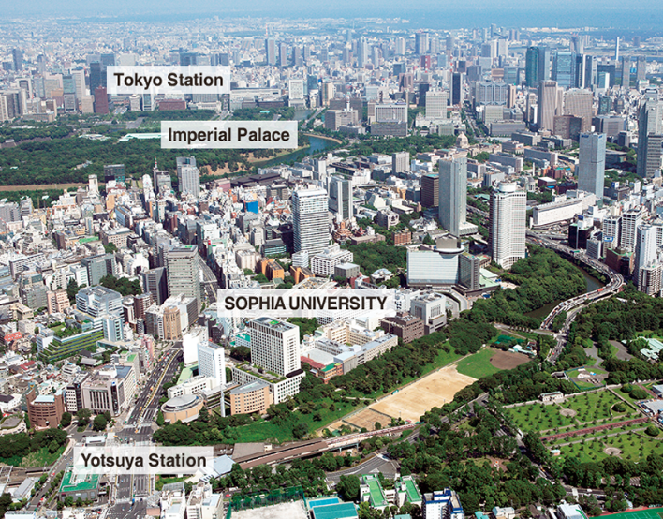

I. Topics & Agenda

Model United Nations:

This year’s MUN will take up three issues: (1) Older Persons in Northeast Asian countries; (2) Persons with Disabilities in Northeast Asian countries; and (3) Women in Northeast Asian countries.

Symposium:

This year`s themes for discussion will be the following:

1. Marine Plastic Pollution

2. Internet and Social Network Service *(SNS)* for Public Communication

II. Tentative Program

25thAugust (Sun)
16:00 Arrival of students from China, Republic of Korea as well as Japan Hotel Le Port Address: 2-4-3 Kojimachi, Hirakawacho, Chiyoda-ku, Tokyo 130-0022 Phone: 81-3-3265-5361
18:00 Welcome get-together dinner Hotel Le Port
26th August (Mon)

09:30~10:30 Opening Ceremony, Sophia University
10:30 -10:45 Group Photo
11:00~12:30 MUN: General Assembly Session
12:30~13:30 Lunch
13:30~18:00 MUN: General Assembly Third Committee Session
18:00~19:00 Dinner

27thAugust (Tue)

09:00~11:00 MUN: General Assembly Third Committee Session
11:00~12:00 MUN: Adoption Session of Resolutions
12:00~13:00 Lunch Sophia University
13:00~14:00 Opening of Symposium Sophia University
14:00~18:00 Symposium Group sessions
Group A: Marine Plastic Pollution
Group B: Internet and Social Network Service *(SNS)* for Public Communication

18:00~19:00 Dinner

28th August (Wed)

07:30~08:30 Breakfast
09:00~12:00 Symposium
Group A: Marine Plastic Pollution
Group B: Internet and Social Network Service Usage and Fake News Literacy
12:00~13:00 Lunch
13:00~17:00 Continuation of Symposium Group sessions
17:00~18:00 Closing Ceremony
18:00~19:00 Dinner
20:00~21:30 Cultural Night
29th August (Thu)

10:00~11:00 Visit Tokyo Dojou Tea Ceremony (Group A)
11:00~12:00 Visit Tokyo Dojou Tea Ceremony (Group B)
12:00~13:00 Lunch with Group Members
13:00~20:00 Guided Tours
A. Harajuku & Shibuya
B. Tokyo Sky Tree & Asakusa
C. Tokyo Edo-Museum& Akihabara

30th August (Fri) Departure of students

